Sales dashboard

Choosing Template

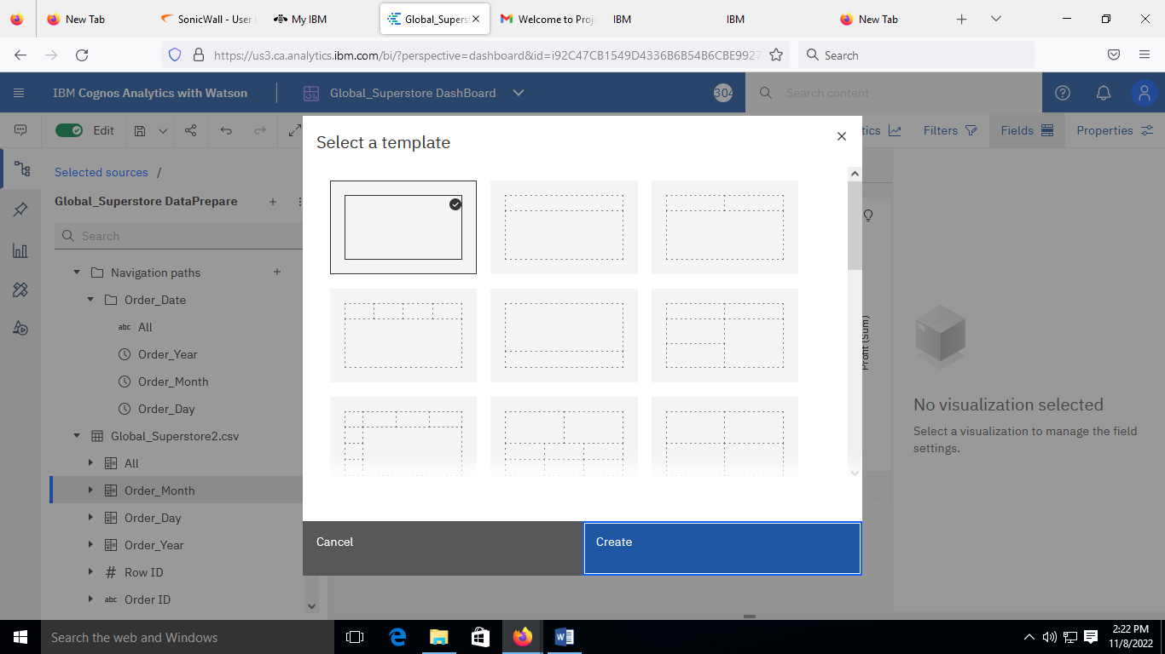

Creating Visualization

Sales dashboard